** **

|  |  |
| --- | --- |
|  |  |

**Faculty of Technology and Engineering**

**Chandubhai S. Patel Institute of Technology**

**Department of Computer Science & Engineering**

**STUDENT’S WEEKLY DIARY/ WEEKLY LOG FOR SGP-II**

|  |  |  |  |
| --- | --- | --- | --- |
| Week No: 5 | | Date | 11/01/23 |
| Division | CSE | Topic | Ticketless Entry to Monuments/Museums |
| Expected Outcome: | Implementation of UI/UX Design | | |
| Name of Students(With Roll No) | 21CS024 , Drashti Mahyavanshi  21CS032, Mahima Mehta  21CS033,Vrushali Mhaskar | | |
| Name of Mentor  With e-mail id | Brinda Patel | brindapatel.cse@charusat.ac.in | |
| Topic | | Implementation of UI/UX Design | |
| Work Done: (Attach Annexure of Work Done)  Implementation of UI/UX Design  Creation of various other pages  Inputs from Mentor/Guide:  Signature of Mentor/Guide:  Exploration done by individuals about the problem statement:  21CS024 , Drashti Mahyavanshi :    21CS032, Mahima Mehta :        21CS033,Vrushali Mhaskar : | | | |

Exploration done by individuals about the problem statement:

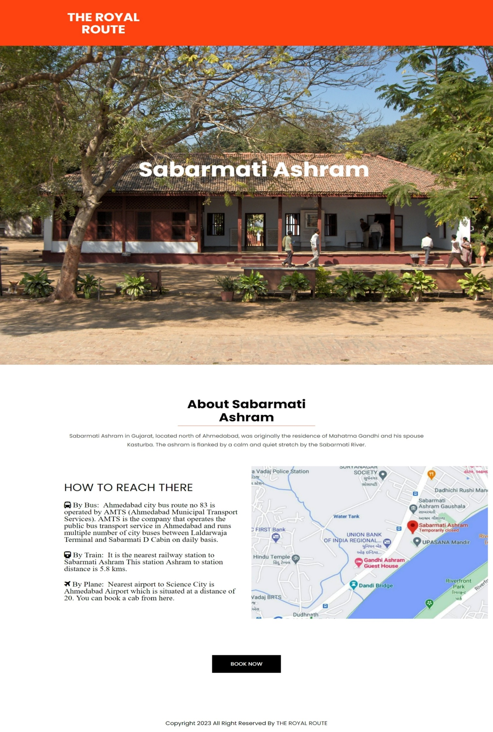21CS024 , Drashti Mahyavanshi :

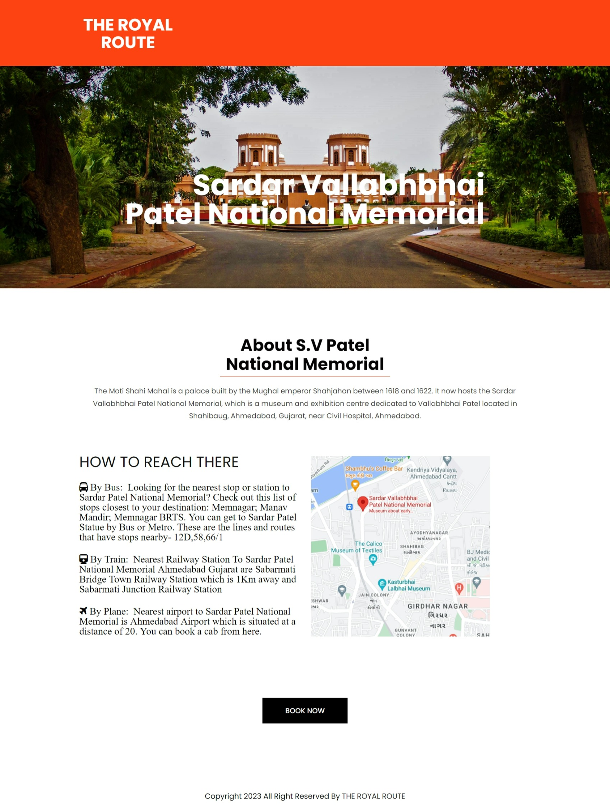

21CS032, Mahima Mehta :

21CS033,Vrushali Mhaskar :

